

**WRITTEN PRACTICE**

REQUIREMENTS AND RESPONSIBILITIES FOR THE QUALIFICATION, CERTIFCATION AND AUTHORISATION OF NDT PERSONNEL

|  |  |
| --- | --- |
| **DOCUMENT NUMBER:** | IQMS-WP-001 |
| **REVISION:** | 00 |
| **DOCUMENT DATE:** | 24 MAY 2017 |

18 Greybeard Road, Sandrift-North, Milnerton, 7441

Tel / Fax: +27(0) 21 555 2973 Mobile: +27(0) 79 957 2869

Email: [cpt@iqms.co.za](mailto:cpt@iqms.co.za) Website: www.iqms.co.za

**Contents**

1. PURPOSE 3

2. SCOPE 3

3. RESPONSIBILITY AND AUTHORITY 3

4. REFERENCES 3

5. DEFINITIONS AND ABBREVIATIONS 4

6. QUALIFICATION AND CERTIFICATION OF NDT PERSONNEL 5

6.1 Qualification and Certification, General 5

6.2 ISO 9712 Qualification and Certification 6

6.3 ASNT CP‑189 Qualification and Certification 8

6.4 ASNT CP‑189 Qualification and Certification Modified for ASME XI Application 9

6.5 SNT‑TC‑1A Qualification and Certification 9

7 VISUAL ACUITY 11

8 COMPANY AUTHORISATION 11

9 RECORDS AND VALIDITY OF RECORDS 13

APPENDIX 1 14

APPENDIX 2 15

ASNT‑CP‑189 Examination Structure and Content 15

ASNT‑CP‑189 Training and Experience Requirements 16

APPENDIX 3 17

SNT‑TC‑1A Examination Structure and Content 17

SNT‑TC‑1A Training and Experience Requirements 18

APPENDIX 4 19

Example of Visual Acuity Records 19

Example of Authorisation Records 20

20

***PLEASE NOTE***

*This Document replaces all previous discussions, understandings and revisions of this written procedure for the Qualification Certification and Authorisation of NDT Personnel utilized by IQMS Group.*

# **PURPOSE**

This document details the practices by which IQMS GROUP administers the Qualification, Certification and Authorisation for all personnel involved in Non-Destructive Testing on behalf of IQMS GROUP.

# **SCOPE**

This document specifies IQMS GROUP’s requirements for:

* + 1. The verification of Qualification and Certification of NDT personnel.
    2. The Authorisation of NDT personnel engaged in activities on behalf of IQMS GROUP.

The methods of non-destructive testing covered by this document are as listed below:

* Magnetic Testing (MT)
* Penetrant Testing (PT)
* Ultrasonic Testing (UT)
* Radiographic Testing (RT)
* Eddy Current Testing (ET)
* Visual Testing (VT)
* Ultrasonic Wall Thickness (UTM)

# **RESPONSIBILITY AND AUTHORITY**

1. IQMS GROUP is responsible to appoint a NDT Level III.
2. IQMS GROUP is responsible to ensure that NDT personnel are suitably Qualified and Certified.
3. IQMS GROUP is responsible to Authorise all NDT personnel to work on their behalf.
4. The QA Manager will be responsible to implement this document under the guidance of the NDT Level III.

# **REFERENCES**

|  |  |
| --- | --- |
| **Normative** | |
| ANSI/ASNT CP-189:1995 | ASNT Standard for Qualification and Certification of Non-destructive Testing Personnel. |
| ANSI/ASNT CP-189:2006 | ASNT Standard for Qualification and Certification of Non-destructive Testing Personnel. |
| ASNT ACCP-CP-1:2012 | ASNT Central Certification Program. ASNT Document ACCP-CP-1 Revision 8. |
| ASNT SNT-TC-1A:2001 | ASNT Recommended Practice No. SNT-TC-1A. |
| ASNT SNT-TC-1A:2006 | ASNT Recommended Practice No. SNT-TC-1A. (2011 EDITION MAY APPLY) |
| EN 473:2008 | Non-destructive Testing Qualification and Certification of NDT Personnel. General Principles. (Superseded by EN ISO 9712:2012). |
| EN ISO 9712:2012 | Non-destructive Testing Qualification and Certification of NDT Personnel |
| ISO 9712:2005 | Non-destructive Testing Qualification and Certification of Personnel |
| Quality Manual | IQMS GROUP QMS |

|  |  |
| --- | --- |
| **Informative** | |
| 32-631 (240-83539994) | Eskom approval of Personnel performing quality related special processes on Eskom plant |
| 32-632 (240-83540088) | Requirements for Non-Destructive Testing (NDT) on Eskom Plant |
| ASNI/ASNT CP-105:2006 | Training Outlines for Qualification of Non-destructive Personnel. |
| ISO 9001:2008 | Quality management systems-Requirements. |
| ISO/IEC 17024:2012 | Conformity assessment-General requirements for bodies operating certification of persons |

# **DEFINITIONS AND ABBREVIATIONS**

|  |  |
| --- | --- |
| **Definitions** | |
| “Not Personal to holder” | Certificates issued to individuals by their employer. Certification is dependent on the employer and is not “personal to holder” and hence certification is not transferable on change of employer and requires re-examination and/or re-certification. ASNT CP-189 and SNT-TC-1A certification is “not personal to holder”. |
| “Personal to holder” | Certificates issued to individuals by accredited bodies. Certification is independent of the employer and is personal to holder and hence certification is transferable on change of employer without further re-examination. ISO 9712 certification is “personal to holder”. |
| Accredited Bodies | Accredited training, qualification and examination bodies meeting the requirements of ISO 17024. Accredited Bodies are referred to as Authorised Bodies in ISO 9712. |
| Authorisation: | Written authorisation attesting that an individual has received requisite training and examination and has gained sufficient experience to carry out NDT tasks defined by IQMS GROUP. This is denoted as “Operating Authorisation” in ISO 9712. |
| Authorised Qualification Body (AQB) | A body, independent of the employer, Authorised by the Certification Body to prepare and administer NDT Qualification examinations eg. SAIW |
| Certification | A procedure, used by the Certification body to confirm that the Qualification requirements for a method, level and sector have been fulfilled, leading to the issuing of a Certificate. |
| Certification Body (CB) | A body that administers procedures for NDT Certification according to the requirements of recognised International Standards eg. SAQCC |
| IQMS GROUP QMS | A Quality Document IQMS GROUP QMS |
| Eskom Approval: | An approval system to assure that (NDT) personnel are working under an approved and controlled system. Eskom Approval is given in accordance with Eskom document 32-631 |
| NDT Level III | In the case of SNT-TC-1A, the individual assigned to qualify and certify other NDT personnel. In the case if ISO 9712, the NDT Level III has no responsibility to qualify and certify other individuals unless engaged by an accredited qualification and certification body. |
| NDT Personnel | Certified individuals in the direct or indirect employ of IQMS GROUP |
| NDT Procedure | A document prepared and authorised by IQMS GROUP which details the procedural requirements for specific NDT methods and techniques. |
| NDT Technique | A specific way of utilising an NDT method e.g. MT current flow using prods. |
| NDT Technique Sheet | Written description of the precise NDT steps to be followed which are developed from the requirements detailed in a NDT Procedure. |
| NDT Training | Process of instruction in theory and practice in the NDT method in which certification is sought, which takes the form of training courses to a syllabus approved by the certification body and specific training not ordinarily covered by a training body, post certification, under the direction of a NDT Level III. All training records shall be documented to support certification. |
| Principal NDT Level III | Individual assigned to qualify and certify other NDT personnel. Has meaning only with regard to ASNT CP-189 and to the qualification and certification of individuals. |
| Qualification | Demonstrated skill/knowledge, documented training and experience required for personnel to properly perform duties of a specific job. |
| Significant Interruption | Absence or change of activity which prevents the certified individual from practising the duties corresponding to the level in the method within the certified scope, as determined by the applicable certification standard. |
| Written Practice | A written procedure developed by the employer that details the requirements for qualification and certification of their employees in accordance with IQMS GROUP QMS. |

|  |  |
| --- | --- |
| **Abbreviations** | |
| ACCP | ASNT Central Certification Program |
| ASME | American Society of Mechanical Engineers |
| ASNT | American Society of Non-destructive Testing |
| BINDT | British Institute of Non-destructive Testing |
| COFREND | Confédération Française pour les Essais Non Destructifs (French Society of NDT) |
| IQMS GROUP | IQMS NDT Group (Pty) Ltd |
| DGZfP | Deutsche Gesellschaft für Zerstörungsfreie Prüfung (German Society for Non-Destructive Testing |
| EN | European Norm |
| ISO | International Standards Organisation |
| NDT | Non-destructive Testing |
| QA | Quality assurance |
| QMS | Quality Management System |

# **QUALIFICATION AND CERTIFICATION OF NDT PERSONNEL**

## **6.1 Qualification and Certification, General**

6.1.1 IQMS GROUP recognise that NDT personnel may be qualified and certified in accordance with the requirements of one, or more, of the following international standards:

* ISO 9712 (includes EN 473 and ASNT ACCP).
* ASNT CP‑189.
* SNT‑TC‑1A.

6.1.2 Normally, the referencing code or standard defines the choice and requirements for the qualification and certification of NDT personnel. Some of these are summarised in Table 1, although the list is not exhaustive:

|  |  |
| --- | --- |
| **Table 1** | |
| **NDT Referencing Code or Standard** | **Standard for Qualification and Certification of NDT Personnel** |
| ASME B31.1: Power Piping | Employer Defined[3]. |
| ASME B31.3: Chemical Plant and Petroleum Refinery Piping | Employer Defined[4]. |
| ASME Section III: Rules for Construction of Nuclear Facility Components | SNT‑TC‑1A. |
| ASME Section V Article 1: Non-Destructive Examination. General Requirements | SNT‑TC‑1A or ASNT CP‑189 or ASNT ACCP. |
| ASME Section VIII: Rules for Construction of Pressure Vessels | SNT‑TC‑1A[1] (Employer Defined). |
| ASME Section XI: Rules for In‑service Inspection of Nuclear Power Plant Components. | ASNT CP‑189[2] or ASNT ACCP. |
| EN European Standards (various) | ISO 9712 (Includes EN 473). |
| ISO International Standards (various) | ISO 9712 (Includes EN 473). |
| *Can be met with the following permissible code options:*  *[1] Is met with ASNT CP‑189 or ASNT ACCP.*  *[2] Or, ASNT CP‑189 with ASME XI reliefs.*  *[3] Is met with AWS QC1 for VT (welds).*  *[4] May use SNT‑TC‑1A.* | |

6.1.3 The IQMS GROUP requirements for qualification and certification are:

1. ISO 9712 which are detailed in §6.2 or
2. ASNT CP‑189 which are detailed in §6.3 and §6.4 or
3. SNT‑TC‑1A which are detailed in §6.5.

6.1.4 IQMS GROUP considers qualification and certification of NDT personnel in accordance with the requirements of ISO 9712 as an alternative way of meeting the requirements of ASNT CP‑189 and SNT‑TC‑1A. When substitution of ISO 9712 is not permitted the specific requirements of ASNT CP‑189 or SNT‑TC‑1A shall be met, as appropriate.

6.1.5 When permitted, IQMS GROUP shall select ISO 9712 in preference to other qualification and certification requirements.

## **6.2 ISO 9712 Qualification and Certification**

6.2.1 Qualification and certification in accordance with the requirements of ISO 9712 is independent of IQMS GROUP and certificates are issued by accredited bodies and the certificates are “Personal‑to‑Holder”, i.e. an individual’s certification does not expire upon termination of employment.

6.2.2 Numerous accredited bodies provide ISO 9712 qualification and certification of NDT personnel. Table 2 lists some of the ISO 17024 accredited bodies acceptable to IQMS GROUP, although this list is not exhaustive.

|  |  |
| --- | --- |
| **Table 2** | |
| **Qualification and Certification Bodies** | |
| ASNT | American Society of Non‑destructive Testing |
| BINDT | The British Institute of Non‑Destructive Testing. |
| COFREND | French Society of NDT |
| DGZfP | German Society of NDT |
| Hobeon SKO (SKNDO) | Operationeel voor de certificatie van Niet-Destructief onderzoekers  Society for the Certification of NDT Personnel (Netherlands) |
| SAIW - Certification | Southern African Institute of Welding - Certification |
| SAQCC | South African Qualification and Certification Committee |

6.2.3 For the accredited bodies selected by IQMS GROUP to qualify and certify NDT personnel, these shall periodically assessed by IQMS GROUP to ensure that the training syllabi, training materials and examination questions are suitable in meeting the needs of IQMS GROUP.

6.2.4 Review of accredited bodies shall be jointly performed by IQMS GROUP QA and NDT Level III personnel and the result of the review confirming ISO 9712 conformity shall be documented. Either a syllabus review or a physical audit shall be performed at least every 24 months on an accredited body, such a review or audit shall be documented. IQMS GROUP reserves the right to accept a 3rd party Audit (eg. SAQCC, SAINT, SANAS or ISO) as sufficient.

* + 1. IQMS GROUP may administer ISO 9712 Qualifications in one or more of the following three ways:

6.2.5.1 When IQMS GROUP makes the arrangement for ISO 9712 training and examination the following steps shall be followed:

1. Prior to certification, personnel shall be considered as trainees. Trainees may not independently perform tests or evaluate results of tests.
2. IQMS GROUP shall administer appropriate in-works and on‑site training and this, together with the experience gained, shall be documented in a personal log of training and experience hours which shall be endorsed by the IQMS GROUP NDT Level III.
3. At a time considered appropriate, formal training at an accredited body shall be arranged by IQMS GROUP. The trainee shall have prior notification of the scheduled training.
4. The trainee shall attend the scheduled training and shall complete, in full, the requisite training as determined by the accredited body. The trainee shall keep the personal log of training and experience hours current.
5. Notification of the formal training hours completed by the individual is issued by the accredited body. This record shall be held in the IQMS GROUP quality documentation system.
6. Where additional training is deemed necessary by IQMS GROUP this shall be scheduled and completed by the trainee. The additional training record shall be held in the IQMS GROUP quality documentation system.
7. Only when IQMS GROUP is satisfied that an individual is suitable for certification shall an examination be arranged at an accredited body. The trainee shall have prior notification of the scheduled examinations.
8. Notification of the examination results is issued by the accredited body. This record shall be held in the IQMS GROUP quality documentation system. The trainee shall keep the personal log of training and experience hours current.
9. Individuals successfully completing examination, and upon receipt of a certificate, shall be considered suitable for IQMS GROUP Authorisation (see §6.2.5.1(h)). A copy of the certificate shall be held in the IQMS GROUP quality documentation system.
10. Individuals failing examination remain a trainee and steps (a)-(i) repeated, as appropriate.
    * + 1. When IQMS GROUP employ individuals already certified in accordance with the requirements of ISO 9712 the following steps shall be followed:
11. The individual’s qualification and certification records shall be submitted to IQMS GROUP, ie training hours, accredited training hours and examination results and experience records.
12. The records shall be reviewed by IQMS GROUP QA and NDT Level III personnel for applicability and validity.
13. Where qualification, certification and experience records are deemed acceptable, IQMS GROUP QA and NDT Level III personnel shall endorse a copy of these records and the copy shall be kept in the IQMS GROUP quality document system.
14. Such individuals shall be considered suitable for IQMS GROUP Authorisation (see §6.2.5.1(h)).

6.2.5.3 When IQMS GROUP sub‑contract an NDT operation, partially or in its entirety, then the following steps shall be followed:

1. The sub‑contractors qualification and certification programme (written practice) shall be reviewed against the requirements of ISO 9712 and the topics commensurate with §6.2.5.
2. Sub‑contractors qualification and certification records shall be submitted to IQMS GROUP, ie training hours, accredited training hours and examination results and experience records.
3. The records shall be reviewed by IQMS GROUP QA and NDT Level III personnel for applicability and validity.
4. Where qualification and certification records are deemed acceptable, IQMS GROUP QA and NDT Level III personnel shall endorse a copy of these records and the copy shall be kept in the IQMS GROUP quality document system.
5. Such individuals shall be considered suitable for IQMS GROUP Authorisation (see §6.2.5.1(h)).
   * 1. The examination structure and content of ISO 9712 is detailed in Appendix 1.

## **6.3 ASNT CP‑189 Qualification and Certification**

Apart from the following rules as per CP-189, all other requirements as listed in CP-189 shall be followed at all times:

6.3.1 Qualification and certification of NDT personnel in accordance with ASNT CP‑189 requires IQMS GROUP to administer training and examinations and to issue certificates to personnel. ASNT CP‑189 certification is “Not‑Personal‑to‑Holder”, ie an individual’s certification expires upon termination of service.

6.3.2 Qualification and certification of NDT personnel shall be administered by the IQMS GROUP NDT Level III(2) supported by IQMS GROUP QA personnel.

*Notes:        (2)The NDT Level III may be one or may be several individuals.*

6.3.3 The Level III will be identified and authorised in writing by IQMS GROUP as the “Principal” NDT Level III(3), ie The Level III responsible for qualifying and certifying other NDT personnel.

*Notes:        (3)The Level III shall be certified in the NDT method for which he is appointed as the Principal NDT Level III. IQMS GROUP may, however, choose to use the services of a third party organisation (so called “outside agency”) to provide the services of a Principal NDT Level III and to administer qualification and certification services on behalf of IQMS GROUP. In such instances IQMS GROUP are responsible for evaluating the outside agency to ensure that the services meet the requirements of ASNT CP‑189 and this document. The responsibility for the certification of NDT personnel is retained by IQMS GROUP.*

6.3.4 The Principal NDT Level III shall hold a current ASNT Level III certificate which satisfies the requirement for Basic and Method examinations. The requirements for Specific and Practical examinations shall be fulfilled if the Principal NDT Level III is required to perform inspections and/or evaluate inspection results (see Appendix 2).

6.3.5 The Principal NDT Level III, supported by IQMS GROUP QA personnel, shall be responsible for ensuring individuals are qualified and certified in accordance with the requirements of ASNT‑CP‑189 and for:

* Assembling and/or approving the IQMS GROUP training materials and training courses and ensuring the minimum training detailed in Appendix 2 is administered to trainees.
* Ensuring that trainees gain the minimum practical experience hours detailed in Appendix 2.
* Assembling and/or approving all NDT examination questions and shall be responsible for the administration and grading of examination results.

6.3.6 On recommendation from the Principal NDT Level III, IQMS GROUP shall be responsible for certifying NDT personnel and for maintaining all records of training, experience and examination in the quality documentation system.

6.3.7 IQMS GROUP may accept previous training, experience and examination records (from other employers) that are documented and can be verified by the IQMS GROUP QA personnel and the Principal NDT Level III. Where such records are deemed to be acceptable, IQMS GROUP may re‑certify such personnel.

6.3.8 When IQMS GROUP sub‑contract an NDT operation, partially or in its entirety, then the following steps shall be followed:

1. The sub‑contractors qualification and certification programme (written practice) shall be reviewed against the requirements of ASNT CP‑189 and the topics commensurate with §6.3.
2. Sub‑contractor qualification and certification records shall be submitted to IQMS GROUP, ie training hours, examination results and experience records.
3. The records shall be reviewed by IQMS GROUP QA personnel and the Principal NDT Level III for applicability and validity.
4. Where qualification and certification records are deemed acceptable, IQMS GROUP QA personnel and the Principal NDT Level III level shall endorse a copy of these records and the copy shall be kept in the IQMS GROUP quality document system.
5. Such individuals shall be considered suitable for re‑certification by IQMS GROUP and authorisation to work (see §6.2.5.1(h)).

## **6.4 ASNT CP‑189 Qualification and Certification Modified for ASME XI Application**

6.4.1 ASME XI requirements allows for ASNT‑CP‑189 qualification and certification to be modified in the following manner.

1. The ASNT‑CP‑189 requirement for the Principal NDT Level III to hold an ASNT Level III certificate to satisfy the Basic and Method examination is not required [ASME XI IWA 2314(a)].
2. The ASNT‑CP‑189 Basic and Method examination requirement can be met as described in §6.5.2 Note 4.
3. When Basic and Method examination requirements are met utilising §6.5.2 Note 4, any such certificate, and for those individuals certified by the Level III, must identify that it is issued in accordance with the requirements of ASME XI and are not in accordance with ASNT‑CP‑189.

## **6.5 SNT‑TC‑1A Qualification and Certification**

6.5.1 Qualification and certification of NDT personnel in accordance with SNT‑TC‑1A requires IQMS GROUP to administer training and examinations and to issue NDT certificates to personnel. SNT‑TC‑1A certification is “Not‑Personal‑to‑Holder”, ie an individual’s certification expires upon termination of service.

6.5.2 Qualification and certification of NDT personnel shall be administered by the IQMS GROUP NDT Level III(4)or(5) supported by IQMS GROUP QA personnel.

*Notes:        (4)If the services of an outside agency are not made use of, the IQMS GROUP QA manager shall be responsible for organising the initial Level III training and examinations in accordance with the requirements of SNT‑TC‑1A and this document. Thereafter, the Level III shall take full responsibility for qualification and certification of other individuals.*

*(5)Individuals in possession of current ISO 9712 or ASNT CP‑189 Level III certificates satisfy the requirements for Basic and Method examinations. The requirements for Specific and Practical examinations shall be fulfilled if the NDT Level III is required to perform inspections and/or evaluate inspection results. Individuals in possession current ISO 9712 or ASNT ACCP Level III certificates satisfy the requirements for Specific and Practical examinations.*

6.5.3 The Level III responsible for the qualification and certification of other individuals will be identified and authorised in writing by IQMS GROUP(6), ie The Level III responsible for qualifying and certifying other NDT personnel.

*Notes:        (6)The NDT Level III shall be certified in the NDT method for which he is appointed. IQMS GROUP may, however, choose to use the services of a third party organisation (so called “outside agency”) to provide the services of a NDT Level III and to administer qualification and certification services on behalf of IQMS GROUP. In such instances IQMS GROUP are responsible for evaluating the outside agency to ensure that the services meet the requirements of SNT‑TC‑1A and this document. IQMS GROUP retain the responsibility for the certification of NDT personnel.*

6.5.4 The NDT Level III, supported by IQMS GROUP QA personnel, shall be responsible for ensuring that individuals are qualified and certified in accordance with the requirements of SNT‑TC‑1A and for:

* Assembling and/or approving the IQMS GROUP training materials and training courses and ensuring the minimum training detailed in Appendix 3 is administered to trainees.
* Ensuring that trainees gain the minimum practical experience hours detailed in Appendix 3.
* Assembling and/or approving all NDT examination questions and shall be responsible for the administration and grading of examination results.

6.5.5 On recommendation from the NDT Level III, IQMS GROUP shall be responsible for certifying NDT personnel and for maintaining all records of training, experience and examination in the quality documentation system.

6.5.6 IQMS GROUP may accept previous training, experience and examination records (from other employers) that are documented and can be verified by the IQMS GROUP QA personnel and the NDT Level III. Where such records are deemed to be acceptable, IQMS GROUP may re‑certify such personnel.

6.5.7 When IQMS GROUP sub‑contract an NDT operation, partially or in its entirety, then the following steps shall be followed:

1. The sub‑contractors qualification and certification programme (written practice) shall be reviewed against the requirements of SNT‑TC‑1A and the topics commensurate with §6.5.
2. Sub‑contractor qualification and certification records shall be submitted to IQMS GROUP, i.e. training hours, examination results and experience records.
3. The records shall be reviewed by IQMS GROUP QA personnel and the NDT Level III for applicability and validity.
4. Where qualification and certification records are deemed acceptable, IQMS GROUP QA personnel and the NDT Level III level shall endorse a copy of these records and the copy shall be kept in the IQMS GROUP quality document system.
5. Such individuals shall be considered suitable for re‑certification by IQMS GROUP and authorisation to work (see §6.2.5.1(h)).

# **VISUAL ACUITY**

7.1 Regardless of the Certification scheme, NDT personnel shall have documented proof of visual acuity which meets the following requirements:

1. **Near-Vision Acuity**

This examination shall ensure natural or corrected near-distance acuity in at least one eye such that the individual is capable of reading a minimum Times New Roman N4.5 or Jaeger Number 1 at a distance of not less than 30cm.

1. **Colour contrast Acuity**

This examination shall demonstrate the capability of distinguishing and differentiating contrast among colours used in the NDT method.

7.2 Verification of visual acuity shall be performed annually and recorded by an optometrist or the NDT Level III. A NDT Technician shall not be allowed to perform any work on behalf of IQMS GROUP unless he/she is in possession a valid Visual Acuity report.

# **COMPANY AUTHORISATION**

8.1 Qualified and certified individuals shall be authorised(7) in writing to undertake NDT on behalf of IQMS GROUP. An example of Authorisation is shown in Appendix 4.

Notes:*(7)Authorisation attests to an individual having received appropriate and sufficient training and examinations and having gained sufficient requisite experience to carry out defined NDT tasks. This is denoted as “Operating Authorisation” in ISO 9712.*

* 1. In order to be considered for Authorisation, NDT personnel shall have the following documents:
* Training Records
* Valid Certification
* Current Experience Records
* Valid Eye Test
  1. The level of Authorisation is based upon Certification and experience.
     1. A NDT Level I may be authorised to:
* Set up NDT equipment
* Perform the inspection to a relevant NDT Technique Sheet/Procedure, approved by a NDT Level III, and work under supervision or guidance of NDT Level II/III personnel.
* Record all indications deemed relevant by the NDT Level II and/or Level III as specified by the applicable Technique Sheet/Procedure.
* Report these NDT results.
* A NDT Level I is **not** authorised to choose test methods or techniques.
* A NDT Level I is **not** authorised to evaluate test results
  + 1. A NDT Level II may be authorised to:
* Undertake the work of a NDT Level I.
* Select the NDT technique for the test method to be used.
* Set up and verify equipment settings.
* Define the limitations of the test method.
* Translate NDT codes, standards, specifications and procedures into NDT instructions.
* Prepare NDT Procedures/Technique Sheets.
* Perform and Supervise inspections at or below NDT Level II.
* Provide guidance for personnel at or below NDT Level II.
* Evaluate and interpret NDT results and report these results.
  + 1. A NDT Level III may be authorised to:
* Assume full responsibility for a test facility and staff.
* Establish, review and validate NDT Procedures/Technique Sheets.
* Interpret codes, standards, specifications and procedures.
* Evaluate and interpret results in terms of existing codes, standards, specifications and procedures.
* Assist in establishing acceptance criteria where none are otherwise available.
* Designate the particular test methods, procedures, work instructions and techniques to be used.
* Provide guidance at all Levels.
* Qualify and Certify NDT Personnel (Specific to CP-189 and SNT-TC-1A)
  1. For any Level of Certification, IQMS GROUP Authorisation may not exceed the limitations imposed by the Certification scheme.
  2. When Certification is given in categories or product sector or industrial sector within a method, Authorisation shall impose commensurate restrictions e.g.
* Categories: Welds, Plate or Pipe or Nozzle welds etc.
* Product Sector: Welding, Casting or Forging.
* Industrial Sector: Pre Service, In Service, Aerospace etc.
  1. A NDT Level III is not authorised to undertake physical inspections or Interpret, Review or Evaluate Test results when:
* The NDT Level III examination did not include a practical examination using the specific methods, techniques, equipment under consideration or
* Is not in possession of a current Level II NDT Certificate related to the specific methods, techniques and equipment under construction.
  1. It is the responsibility of IQMS GROUP Level III to ensure that the requirements of Authorisation are met. The Authorisation is valid until the expiry date of Certification. Authorisation will expire should Certification be revoked by the Certification Body, AQB or Employer.
  2. The IQMS GROUP Level III will perform periodic assessments to confirm suitability for continued Authorisation. Where irregularities or non-conformances are observed, Authorisation may be withdrawn. Scope of Authorisation shall be documented and IQMS GROUP may authorise NDT personnel at a Level lower than their qualification certification.
  3. When IQMS GROUP sub-contracts NDT Personnel, IQMS GROUP may accept Qualification and Certification by the sub-contracted IQMS GROUP, in accordance with CP-189 and/or SNT-TC-1A, as sufficient. Where such records are deemed to be acceptable, IQMS GROUP may authorise such personnel.

# **RECORDS AND VALIDITY OF RECORDS**

* 1. All certificates of Qualification and/or Certification shall be verified either telephonically or in writing by the issuing Institution.
  2. All documents shall be kept as per IQMS GROUP’s QMS.

# **APPENDIX 1**

**ISO 9712 Examination Structure and Content**

|  |  |  |  |
| --- | --- | --- | --- |
| **NDT Level** | **Examination Structure and Content** | | |
| Level III | Basic Examination | Main Method Examination | Practical Examination(1) |
| Level II | General Examination | Specific Examination | Practical Examination |
| Level I | General Examination | Specific Examination | Practical Examination |
| Notes:  (1)Individuals holding a current Level II certificate, in the same method, satisfies the requirement for Practical Examination at Level III | | | |

# **APPENDIX 2**

## **ASNT‑CP‑189 Examination Structure and Content**

|  |  |  |  |  |
| --- | --- | --- | --- | --- |
| **NDT Level** | **Examination Structure and Content** | | | |
| Level III(6) | Basic Examination(1) | Main Method Examination(1) | Specific Examination(2) | Practical Examination(3) |
| Level II(7) | General Examination | Specific Examination(4) | Practical Examination(5) |  |
| Level I | General Examination | Specific Examination(4) | Practical Examination(5) |  |
| Notes:  (1)Individuals holding a current ASNT Level III certificate, in the test method, satisfy the requirement for Basic and Main Method Examinations. Only those individuals holding current ASNT Level III certificates can be appointed as a Principal Level III.  (2)The employer shall administer a Specific Examination related to specifications and standards pertinent to the employer.  (3)The employer shall administer a Practical Examination if the duties of the Level III require performing tests or evaluating test results. A current Level II certificate, in the test method, satisfies the requirement for Practical Examinations.  (4)The Specific Examination shall be related to equipment, procedures and techniques that are to be used.  (5)The Practical Examination shall be with samples representative of the items to be encountered.  (6)(7)Individuals holding a current ACCP certificate, in the test method, satisfy all examination requirements. | | | | |

## **ASNT‑CP‑189 Training and Experience Requirements**

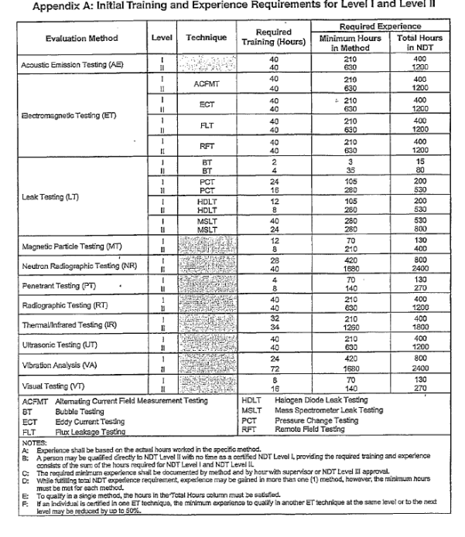

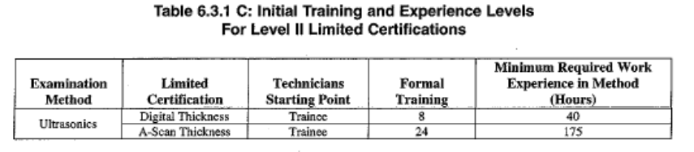

# **APPENDIX 3**

## **SNT‑TC‑1A Examination Structure and Content**

|  |  |  |  |  |
| --- | --- | --- | --- | --- |
| **NDT Level** | **Examination Structure and Content** | | | |
| Level III | Basic Examination(1) | Main Method Examination(1) | Specific Examination(2) | Practical Examination(3) |
| Level II | General Examination | Specific Examination(4) | Practical Examination(5) |  |
| Level I | General Examination | Specific Examination(4) | Practical Examination(5) |  |
| Notes:  (1)Individuals holding a current ASNT Level III certificate, in the test method, satisfy the requirement for Basic and Main Method Examinations.  (2)The employer shall administer a Specific Examination related to specifications and standards pertinent to the employer.  (3)The employer shall administer a Practical Examination if the duties of the Level III require performing tests or evaluating test results. A current Level II certificate, in the test method, satisfies the requirement for Practical Examinations.  4The Specific Examination shall be related to equipment, procedures and techniques that are to be used.  5The Practical Examination shall be with samples representative of the items to be encountered. | | | | |

## **SNT‑TC‑1A Training and Experience Requirements**

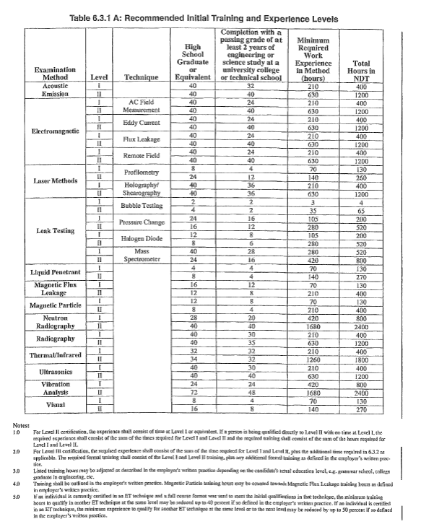

# **APPENDIX 4**

## **Example of Visual Acuity Records**

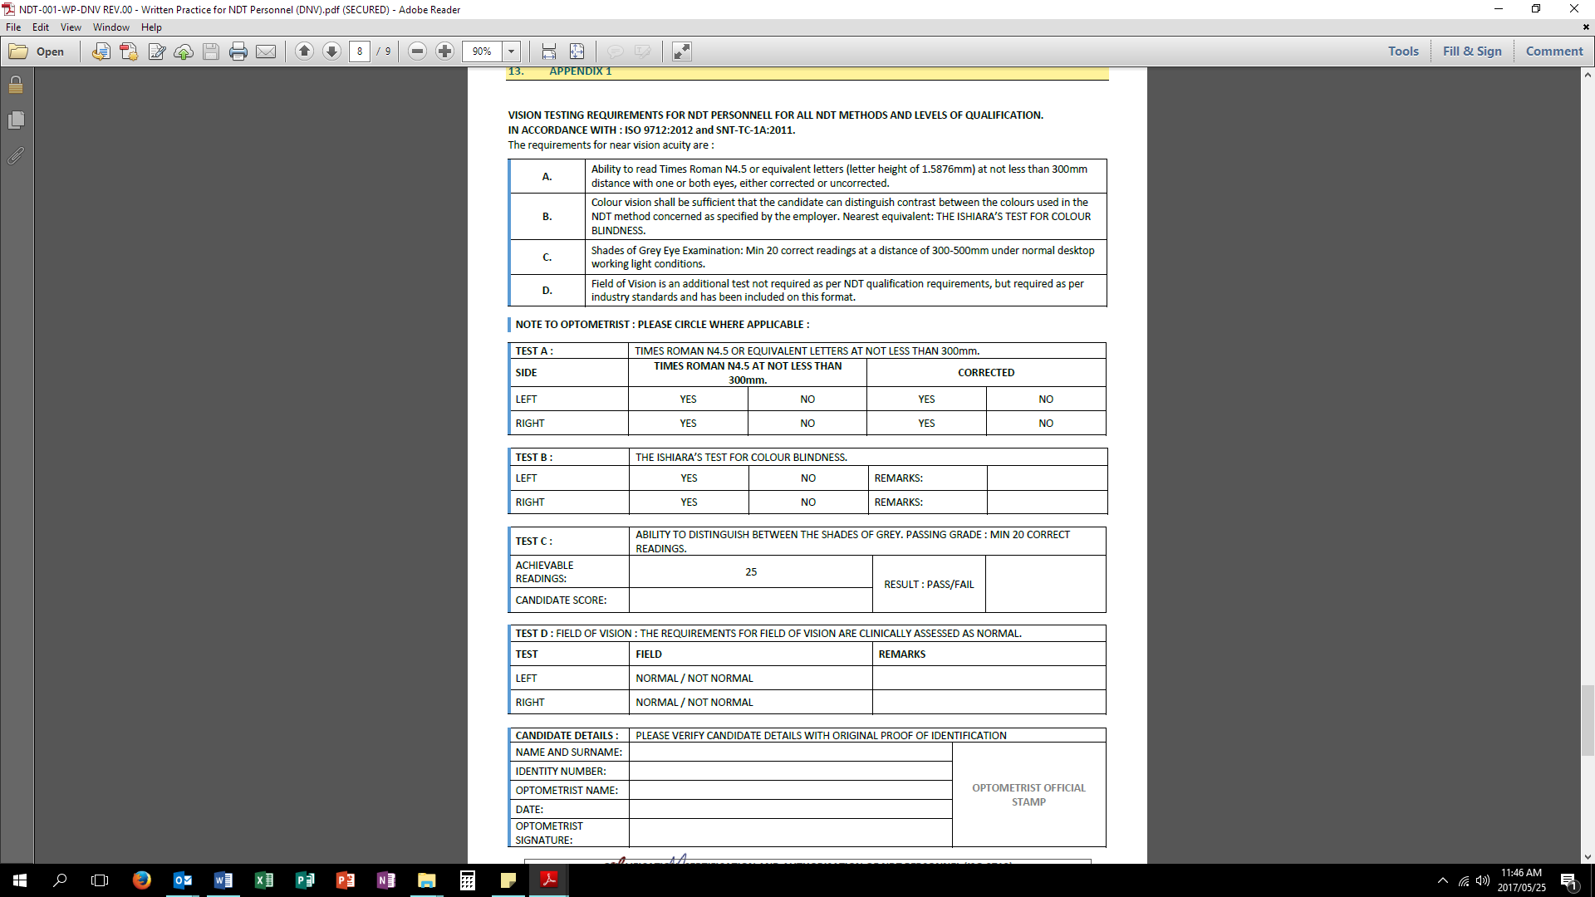

Page **20** of **20**

## **Example of Authorisation Records**

## 

|  |  |  |  |  |  |
| --- | --- | --- | --- | --- | --- |
| **REQUIREMENTS AND RESPONSIBILITIES FOR THE QUALIFICATION, CERTIFICATION AND AUTHORISATION OF NDT PERSONNEL** | | | | | |
| **COMPILED BY:** |  | **IQMS GROUP:** | IQMS GROUP | | |
| **APPROVED BY:** |  | **DOCUMENT NO:** | IQMS-WP-001 | **REVISION:** | 00 |
| **REVIEWED BY:** |  | **DOCUMENT DATE:** | 24 MAY 2017 | **EXPIRY DATE:** | 31 MAY 2018 |